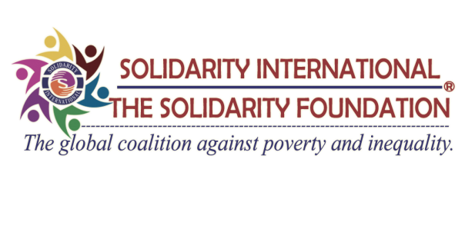

Membership Application Form
 | Name
 | Age/DOB
 | Gender Male Female
How do you know about Solidarity International?

If you have participated in any Solidarity International’s program?
Please mention below.

 | Permanent Address
 | Temporary Address
 | Profession | Current Organization Name:  Address:  Contact No.:
 | Education
 | Personal Information | Contact No.:  E-mail Address:
 | Area of Interest | Humanitarian Affairs Leadership Development  International Relation Others:
 | Will you able to pay yearly membership due of NRs 1,500? | Yes No
Why do you want to be a part of Solidarity International and how can you contribute to Solidarity International?

Which communication method do you prefer to use? Mention below as per your priority.
(Personal email address, mobile phone, SMS, Solidarity International Facebook Page)
a.
b.
c.
d.

I understand and accept the principle of Solidarity International as expressed in its purpose and objectives and agree to comply with and be bound by the “Solidarity International Constitution”, “Solidarity Statement of Policy”, and by-laws of the chapter.

Signature: …………………………………………..

Date: ……….……………............................

Note: Please enclose a copy of your citizenship certificate and your CV along with this application.

Send this Application Form to:
Solidarity International (SI)
Dillibazar, Kathmandu
Bagmati, Nepal
Tel: - +977-1-2299688 (O) +977-9851049804 (M)
Fax: - +977-1-2299688
Email: foundationsolidarity@gmail.com
Website: www.solidarityinternational.net, www.solidaritynepal.org

“THANK YOU”

